# Staff Client

## Installation

* To access the staff client of Super Test, go to <http://i3-uc-client.s3-website-ap-southeast-2.amazonaws.com/login>
* Log-in with credentials, some test credentials are as follows
  + Username Password
  + 10110111 uc
  + 10236121 uc
  + 10254227 invigilator
  + 11311921 uc
  + 11311925 invigilator

## Use

* When you log in, you will be taken to a dashboard screen which looks like this.

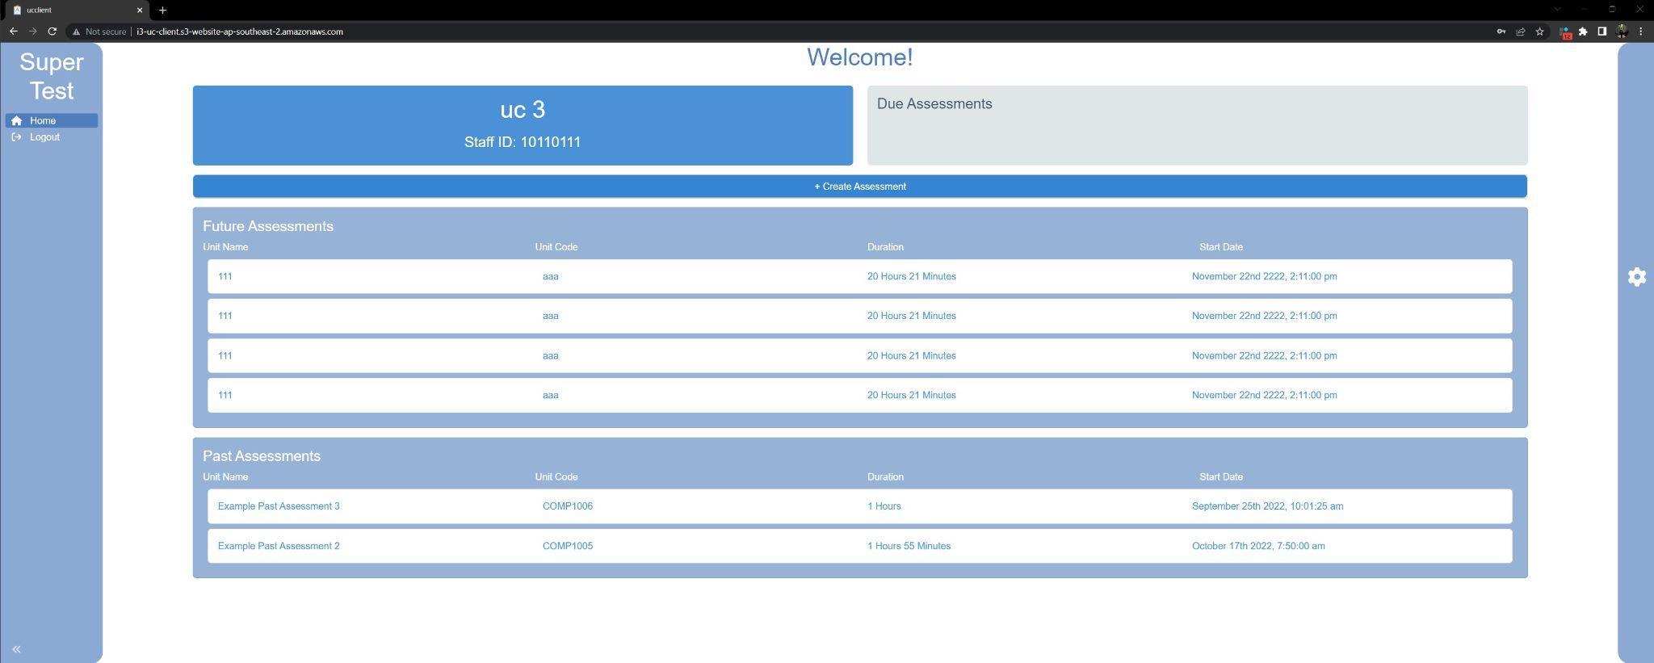

* On this screen you can see all of the future assessments and past assessments.

### 

### Assessment Creation

* To Create an assessment, click on the blue create assessment button seen on the dashboard

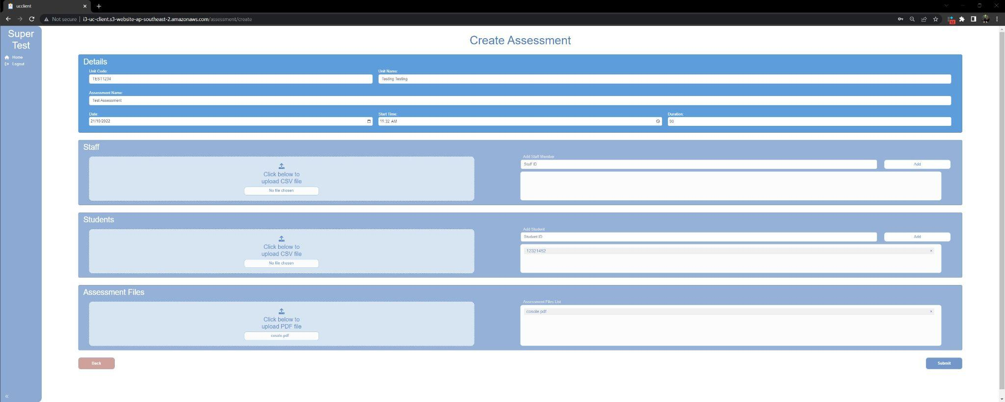

* This will take you to a screen which looks like this. From here, fill out each field with the information you would like to provide. Then in the staff box, you can upload a CSV with staff numbers separated by a comma or manually enter them (make sure to click add). Do the same thing with the student section to add the students which will need to sit the assessment.
* In the assessment files section, upload any PDF files which may be needed, such as the assessment sheet.
* Once you have all of the documents in which you want, click submit and a notification saying assessment created successfully should appear.

### 

### View Active Assessment, Answer Questions, Send Notifications

* When an assessment is available to join, it will appear on the dashboard seen in the screenshot below.

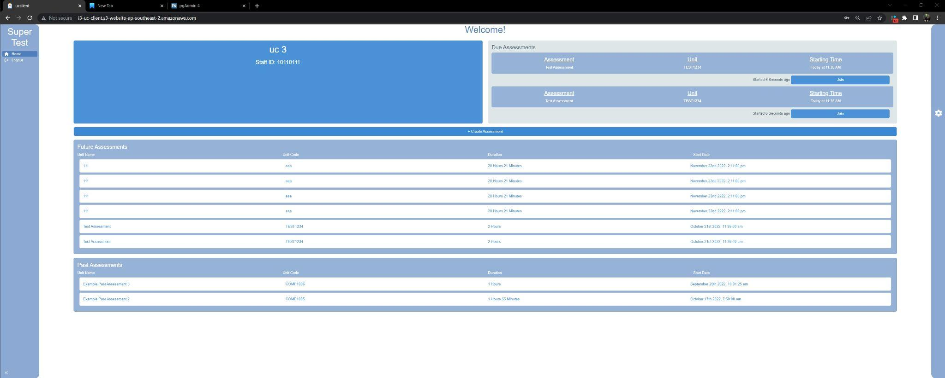

* To join an assessment, click the button which is labeled join in the due assessments box in the top right.
* This will then take you to this screen.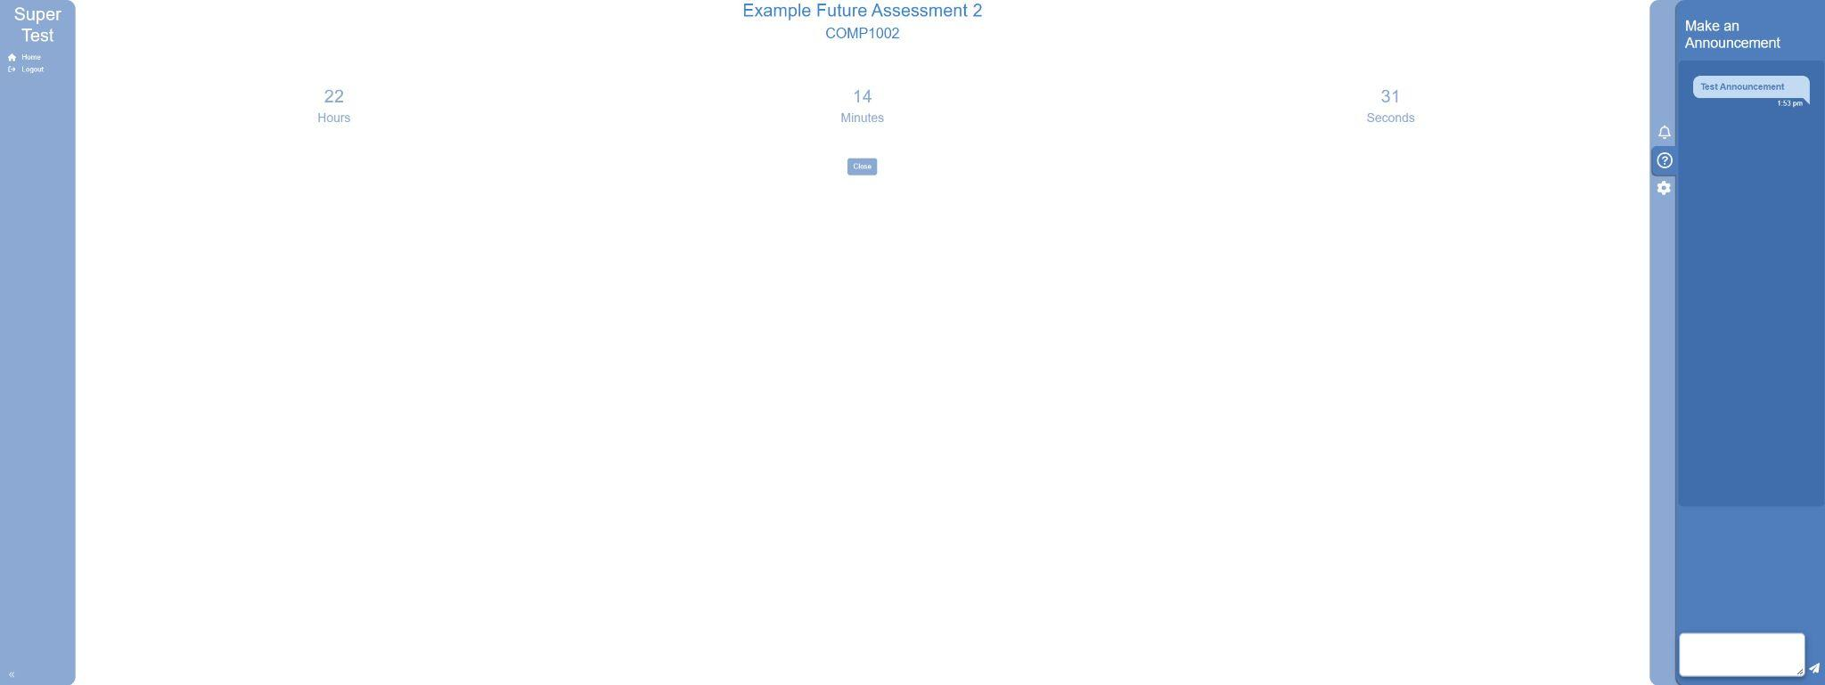
* This screen features a live countdown timer, as well as an announcement section and a question/answer section.
* From here, if you click on the question mark on the right sidebar, it will allow you to make an announcement which will go out to all the students.
* If you click on the bell icon, you can see any questions from the students and send them an answer.
* If you would like to exit this screen, you can click on the home button on the left sidebar or the close button in the middle of the screen.

# Student Client

## Installation

Without Sudo Access

* Download the linux package from this link (named SuperTest_0.1.0_amd64.deb) on a linux device: <https://drive.google.com/drive/folders/1m7SHW_q89XeyHGFNwIvJgXped9vdj0h8>
* Open the folder which this downloaded to, most likely downloads, right click and select open in terminal.
* Run the command: *ar x SuperTest_0.1.0_amd64.deb*
* This will then unpack two folders into the working directory, data.tar.xz and control.tar.gz
* Right click on these folders and select extract here
* From here, go to data -> opt -> SuperTest, right click and select open in terminal
* Run the command ./supertest

With Sudo Access

* If you have sudo access on the machine, run:  
  *sudo dpkg -i SuperTest_0.1.0_amd64.deb*
* From the desktop: Show Applications -> type “SuperTest” on the search bar, an Electron application called “SuperTest” will show up.
* From the terminal: type “supertest” on command line

## 

## Use

From here you will be taken to a login screen, some test credentials are below:

* 12152830 student
* 12321452 student
* 12389452 student
* 17520121 student
* 18457890 student
* 18906353 student

When you log in, you will be taken to the below screen.

* On this screen, you can view your student details, all future assessments and all past assessments. 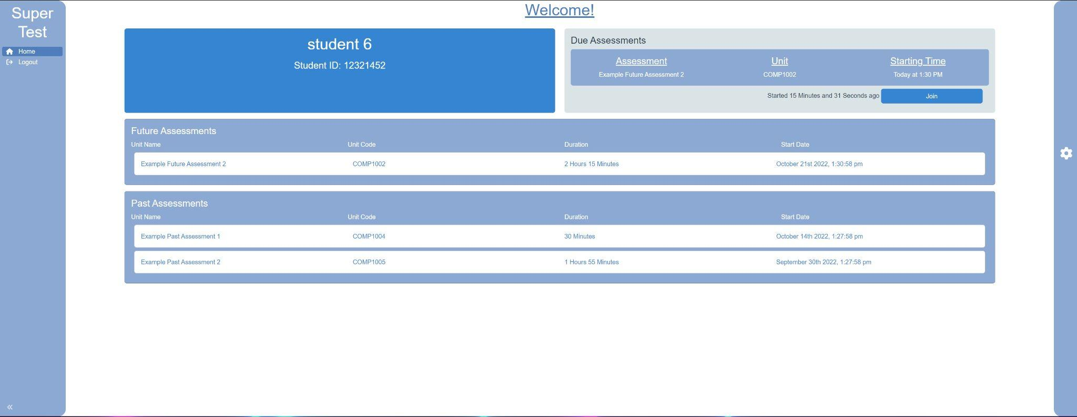
* If you have an assessment which is available, you can select the join button in the Due assessments box. This will take you to the pre-assessment screen shown below.

### Sitting an Assessment

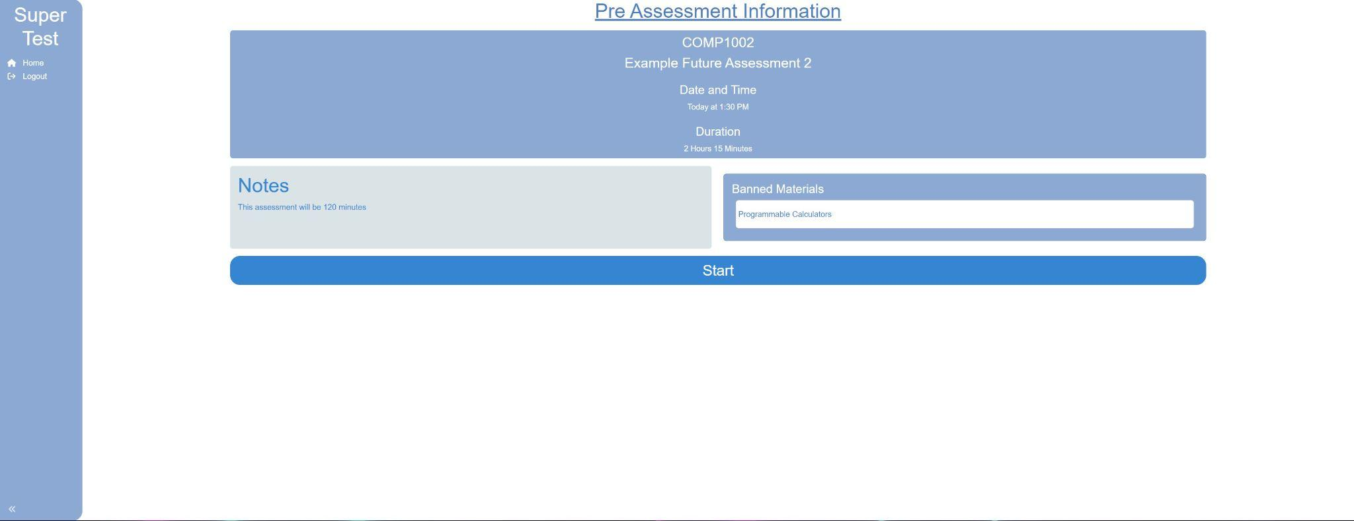

* On this screen you are able to view all the pre-assessment information. When you click on the start button, a working directory will be created and populated with assessment files. You will be directed to the active assessment page.

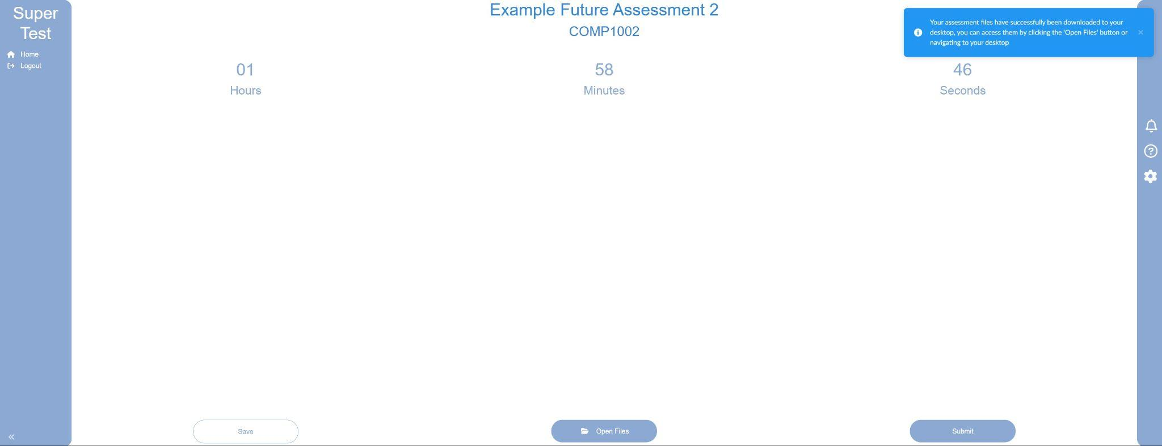

* This screen is the active assessment page. When you first enter it, there will be a notification saying that a working directory has been created. If you click on the open files button it will take you to that working directory. 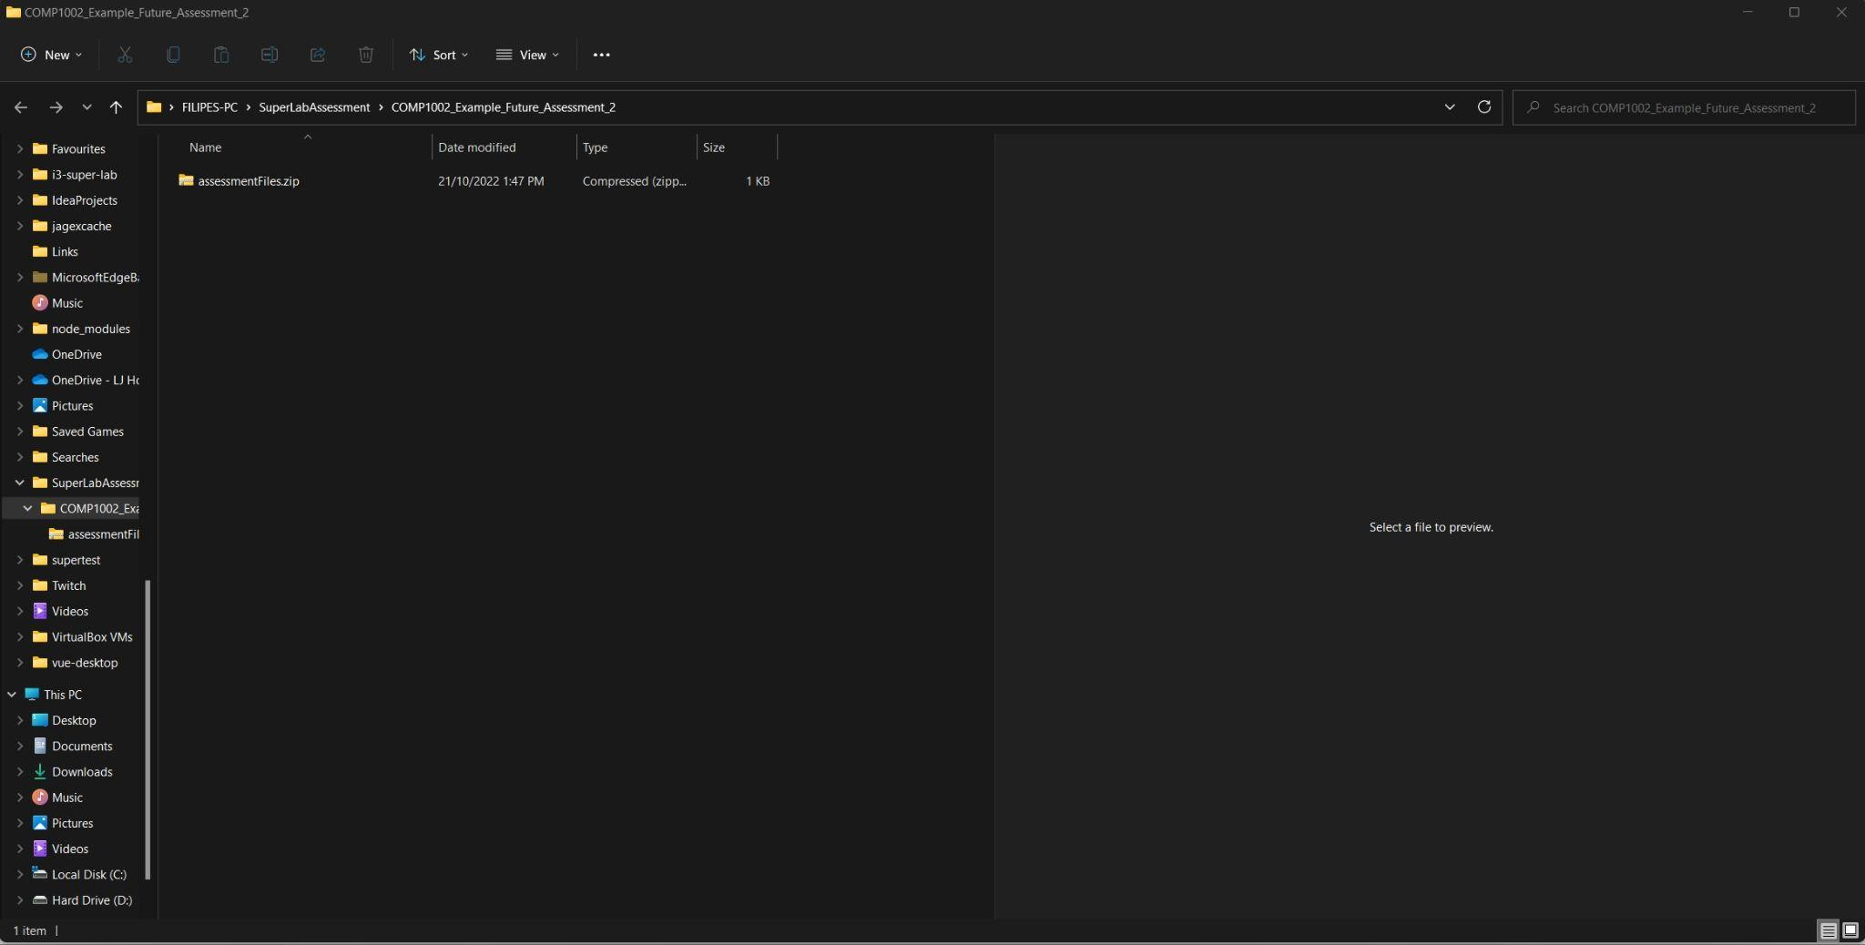
* Periodically, the RSync module will perform autosaving. This will be apparent by the system pushing a notification saying “your work has been saved”. This can be manually performed by clicking the save button in the bottom left corner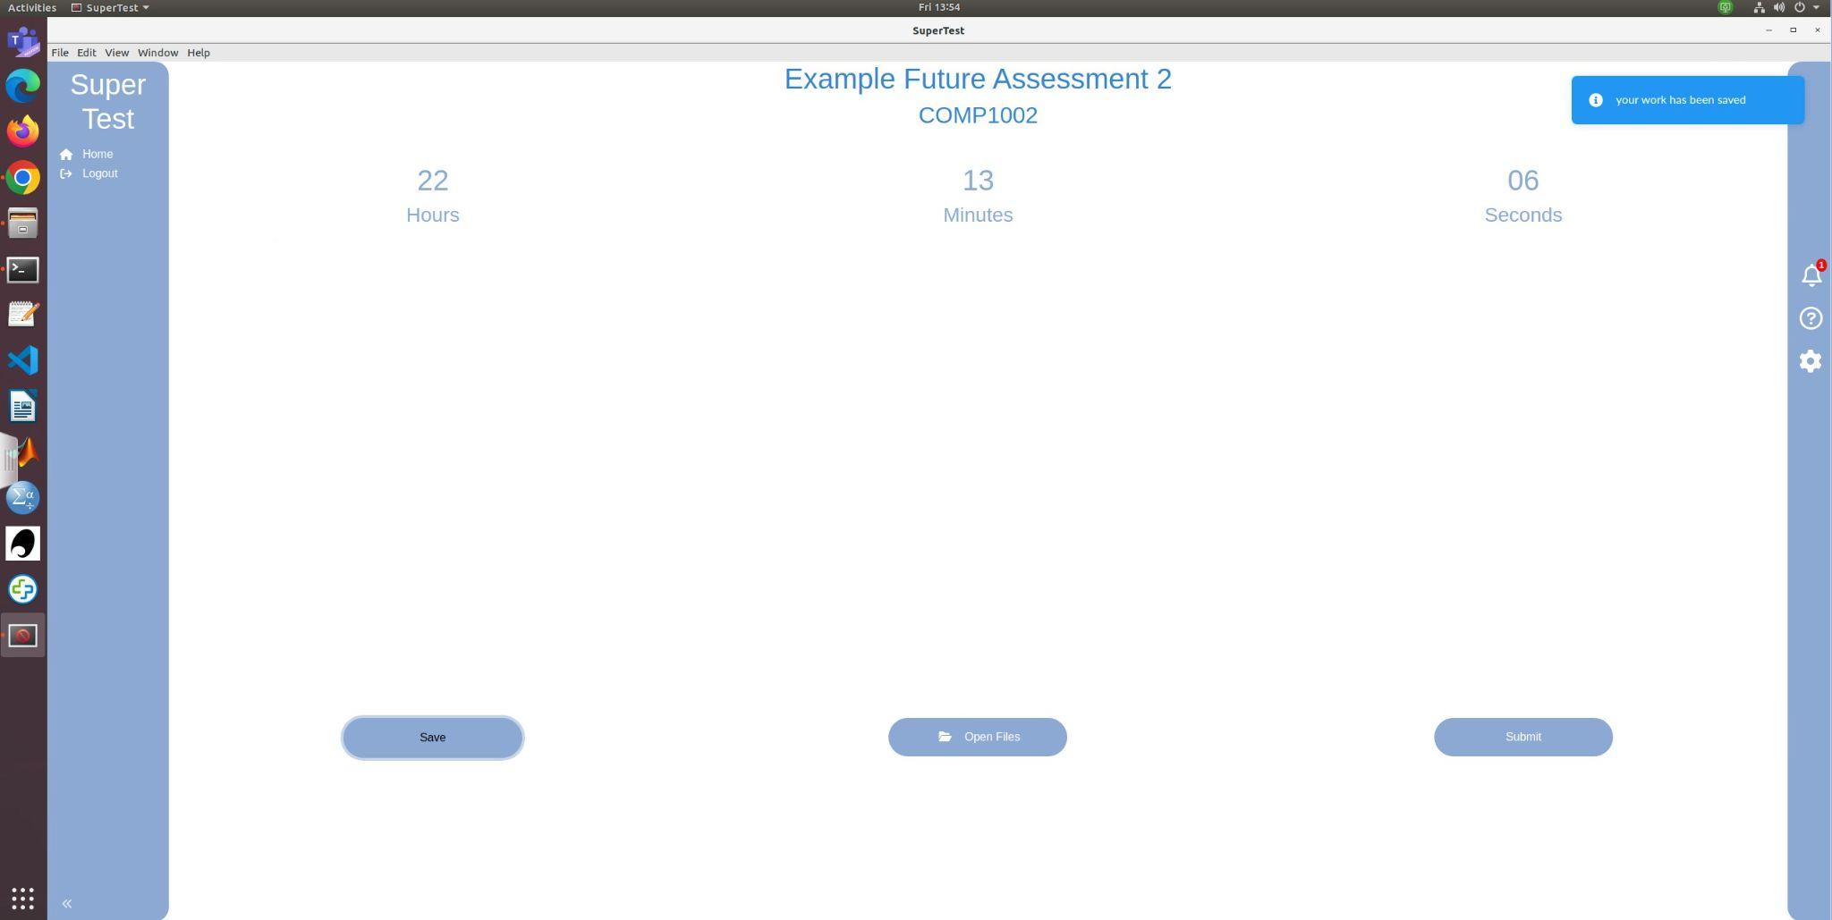
* If you would like to submit the assessment, click on the submit button and it will take you back to the dashboard.

### Asking Questions/Viewing Announcements.

* To ask a question, click on the help icon on the right side. This will then make a question box available to ask any questions. 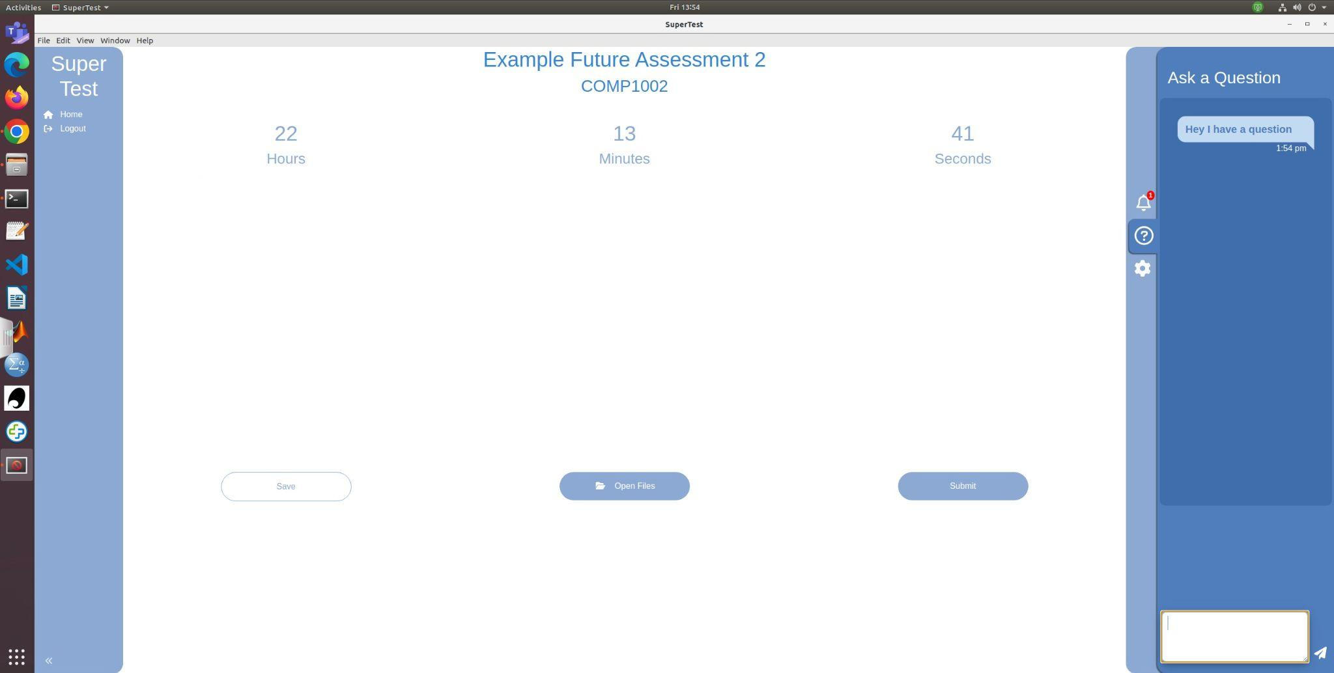
* To view any unit coordinator announcements, click on the bell icon and it will show any new announcements. This will be apparent as there will be a red number next to the bell icon. 